Student Patent Novelty Check – Project Kickoff Document
Introduction
The goal of this project is to build a simple, student-friendly tool that helps users understand whether their idea might already exist in the world of patents. Instead of expecting students to navigate complex search interfaces or interpret CPC codes on their own, the tool guides them through a structured intake form, analyzes their descriptions with lightweight AI logic, and produces a set of similar patents they can explore.
Over the past week, I have developed the first fully functional prototype — something that can accept a student's idea, interpret it, map it to likely CPC categories, and return mock search results. This prototype gives us a realistic sense of how the final tool may behave and has laid a strong foundation for the next phases of development.

Work Completed So Far
Building the Backend
To support all the logic behind the scenes, I set up a clean Python-based backend using FastAPI. I created a virtual environment, installed the necessary dependencies, and wrote the core endpoints that the frontend communicates with.
The system currently supports:
- A health check endpoint so we can test whether the backend is live
- An endpoint that reads the student’s input and suggests likely CPC codes based on keywords
- A search endpoint that (for now) returns well-constructed mock patent results based on the CPC suggestions
These endpoints are working reliably, and I’ve tested them through Swagger UI and direct JSON calls. The backend is stable and ready for advanced features once the CPC logic and real patent datasets are ready.
Developing the Frontend
I created a new Next.js application and designed an interface that mirrors the wireframes we discussed. The UI includes:
- A guided text box where the student describes the problem
- Checkboxes that help them categorize what the idea does
- A dropdown to choose a domain
- A list of technologies they can select
- A short box for describing what’s new or unique about their idea
Using the “Find Similar Patents” button, the frontend sends the idea to the backend, receives the output, and displays the results.
End-to-End Testing
To ensure everything works properly, I tested the entire flow using a realistic industrial example involving PLC-controlled machinery. This test confirmed that:
- The UI sends the right structured data
- The backend interprets the problem and technologies correctly
- CPC categories returned by the backend match the domain of the idea
- The final set of mock patents is displayed cleanly to the user
This confirms that the full pipeline is functioning and ready for deeper logic and real datasets.
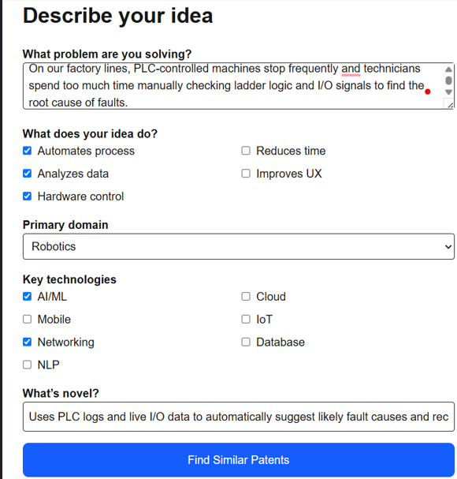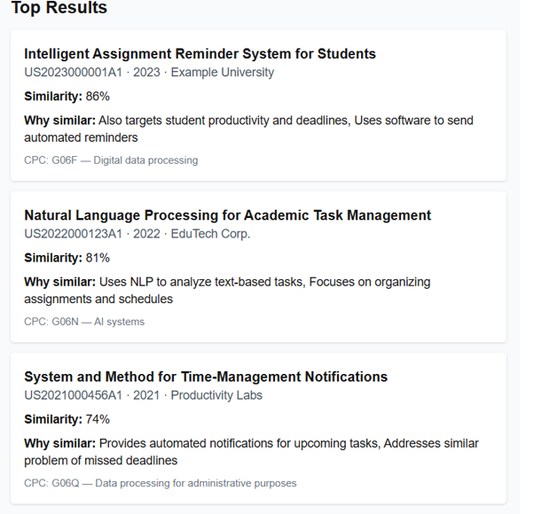

Resources Needed Moving Forward
To make the tool robust and useful for students across different departments, we will need a few important resources as the project progresses.
Patent Data Sources
We will eventually require access to real patent data. Fortunately, there are several open data sources we can use — such as WIPO, USPTO, Lens.org, or Google Patents’ public datasets — depending on the depth and complexity we want to support. These will allow us to generate true similarity comparisons rather than mock results.
AI Models and Tools
As we refine similarity detection, we will likely use an embedding model or lightweight text classifier. This doesn’t need to be heavy or expensive; even basic semantic models are enough to identify overlapping concepts. Tools like Cursor or VibeCode will be helpful in speeding up development and keeping the code clean.
Deployment and Hosting
Eventually, we'll need to host the backend, frontend, and possibly a small database. A basic hosting platform (Render, Azure, or even university servers) will be sufficient.
Human Guidance
We will also rely on feedback from subject matter experts (e.g., Shiva and Erik) to refine the CPC mapping logic and to validate whether the guided form aligns with the way real patent evaluations are performed.

Planned Timeline
The project can reasonably be completed in 3–6 months, depending on how deeply we integrate real datasets and semantic search.
Phase 1 – Prototype (Completed)
The core system is already running:
Frontend → Backend → CPC suggestions → Mock patent results
Phase 2 – Enhancing CPC Logic (Weeks 1–2)
During this phase, I will expand the CPC rules, improve keyword extraction, and refine the guided questions so that each input result is mapped more accurately to CPC classes.
Phase 3 – Integrating Real Patent Data (Weeks 3–7)
Here we begin pulling real patent abstracts and metadata into the system. This will allow us to do real comparisons and not just approximate ones.
Phase 4 – UI/UX Refinements (Weeks 7–9)
I will refine the layout, add more intuitive elements (like expandable patent cards), and incorporate feedback from early testers.
Phase 5 – Pilot Testing (Weeks 9–16)
A group of students will try the tool and give feedback about clarity, usefulness, and accuracy. Their responses will guide the final iteration.

What Kind of Feedback We Expect from Users
To improve this tool, feedback from real students will be crucial. We’re not just testing whether the code works — we’re testing whether the experience makes sense and whether the suggestions feel helpful.
Here is the type of feedback we hope to gather during pilot testing:
1. Clarity of the Guided Input
Do students understand what each question is asking?
Does any field feel confusing, too technical, or unnecessary?
2. Accuracy of the Suggested CPC Categories
Do the CPC classes shown seem relevant to the idea?
Are there cases where the suggestions feel far off or too broad?
3. Usefulness of the Similar Patent Results
Do students feel like the returned patents match the spirit of their idea?
Do they get a better sense of novelty after reviewing the results?
4. Ease of Use
Is the interface intuitive?
Do students feel overwhelmed or is the process smooth?
Are there points where they don’t know what to type?
5. Confidence and Transparency
Do students understand why the tool suggested certain patents?
Would an explanation panel (“Why this patent is similar") make them feel more confident?

